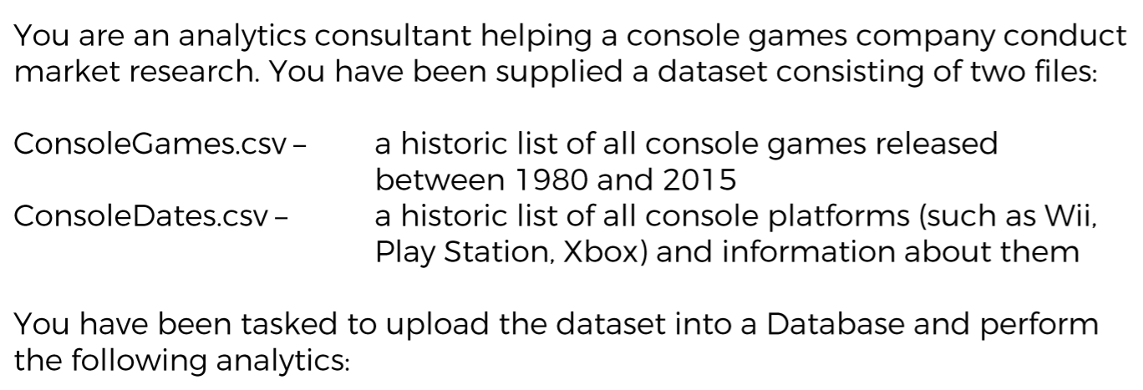

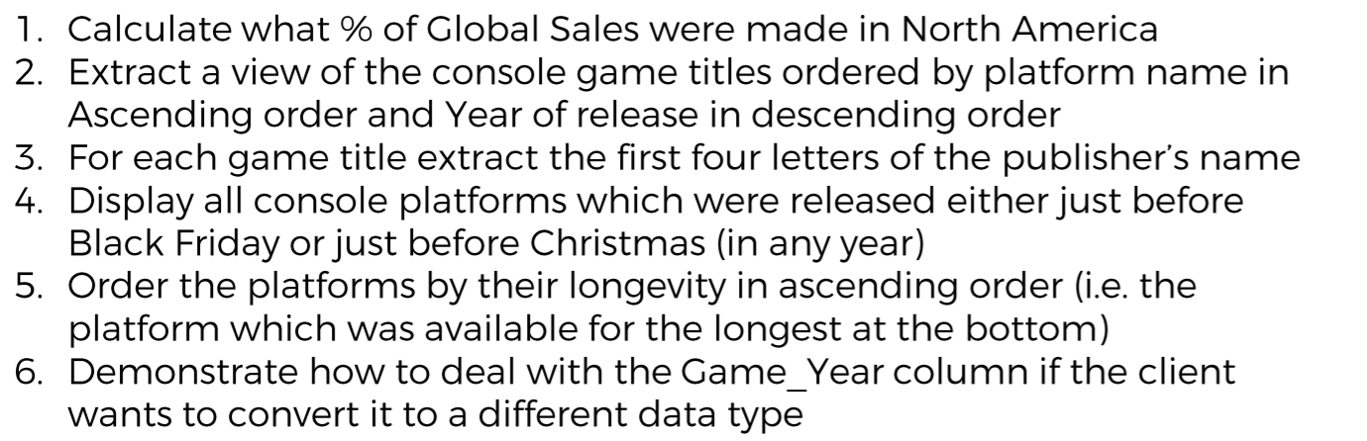

Final Report task:

Please create a set of reports which showcase the hit games by

1.Country

2.Platform

3.Yearly based of consoles sold in millions